When we create a bean, it’s by default a **singleton**. This means only one copy of the object is created and shared across.

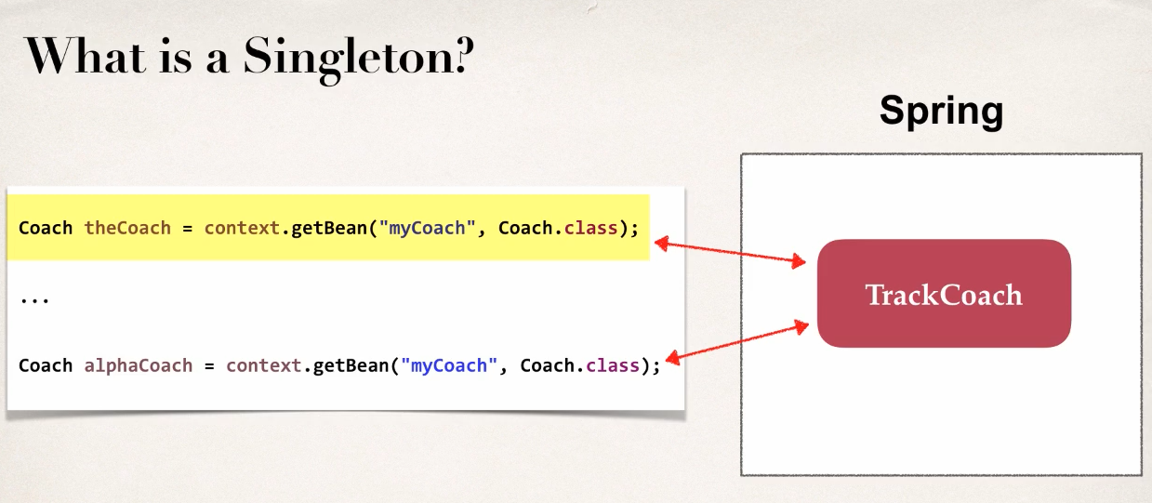 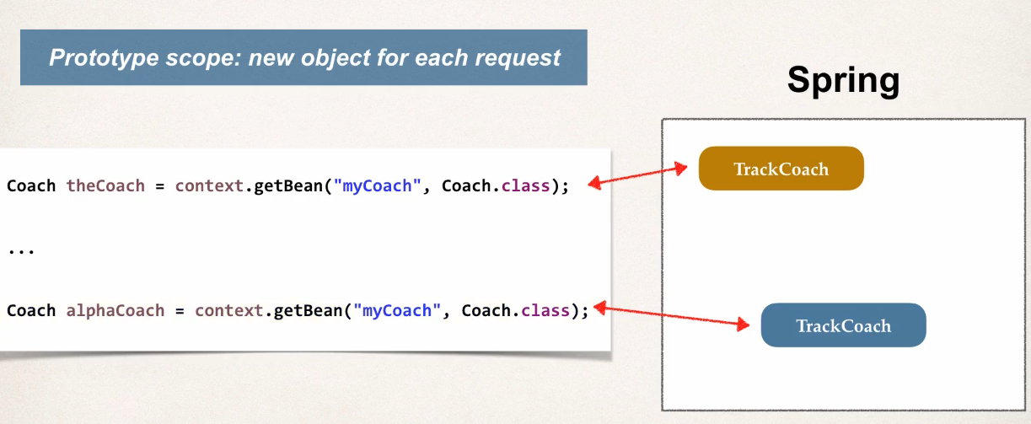

If we use **prototype** scope, it will make new object for every request of the bean. We can test this theory by printing two objects. If they are singleton they will both have same memory address, if prototype different memory address.

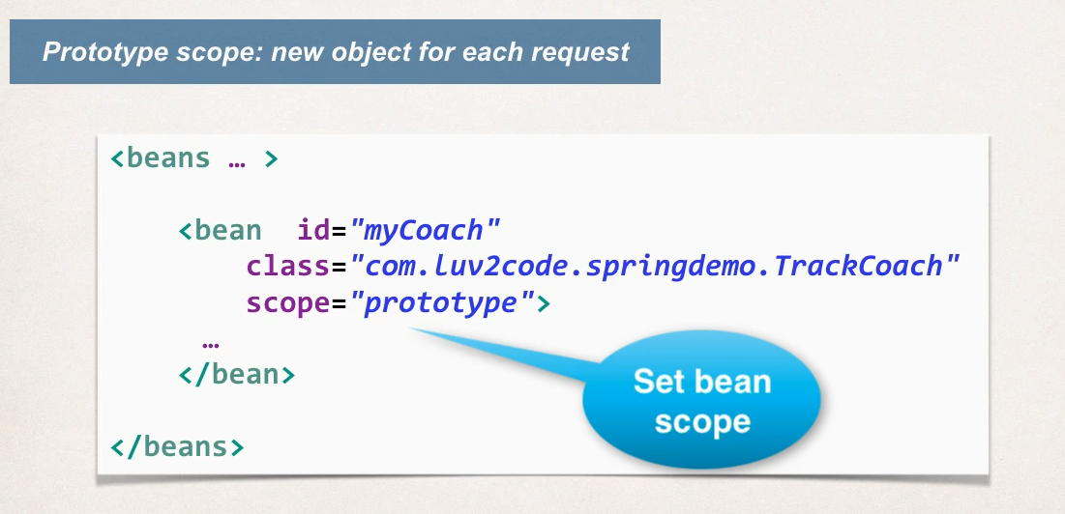

We can specify the scope of a bean to various types.

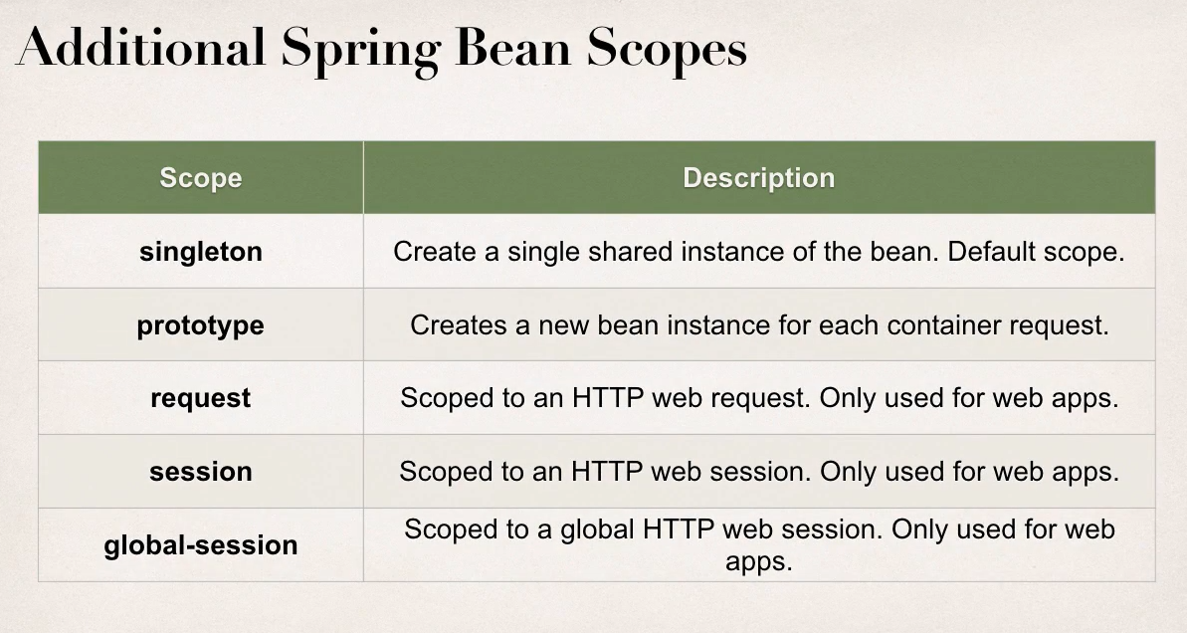

**Bean Life-Cycle:** We can insert our custom initialize and destroy methods. These methods are run automatically during creating and destruction of the context (Or bean?? Have to confirm)

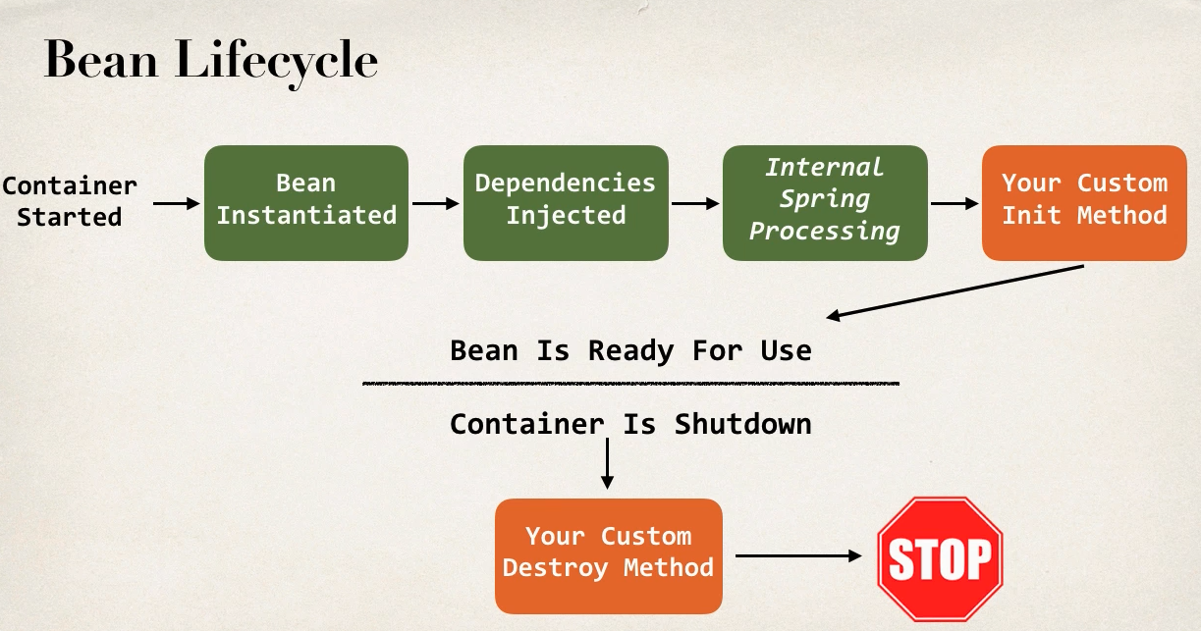

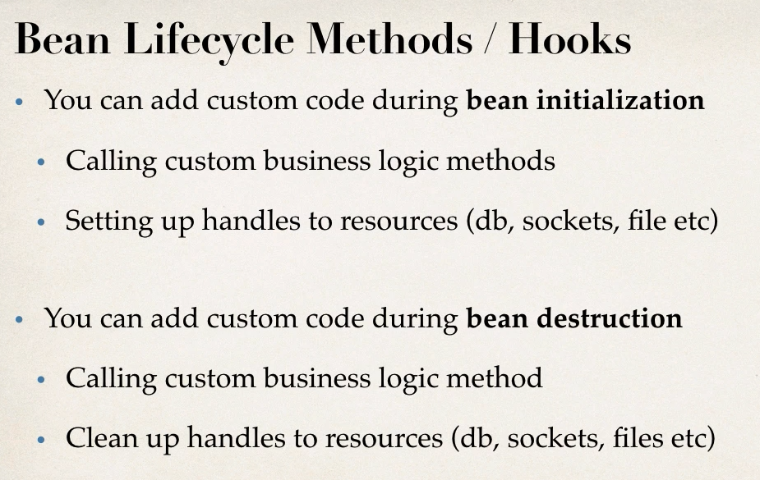

For configuring these methods in the application context file,

